

electronic Customs management system
User Guide

On

Temporary Storage - aPPROVAL

Version: 1.0
Date: 05/09/2022

About Yang Khor Pvt Ltd

Yang Khor IT Solutions is a leading In-country Technology Solutions Provider providing solution in terms of hardware, software, support, and services as its complete package.
Yang Khor IT Solutions has been serving its purpose since 2005, it now has emerged to be an unprecedented leader as a Solution Integrator with a differentiated vertical approach to providing innovative solutions. Yang Khor uses its solution integration capabilities to integrate best-of-breed products through its key technology alliance partners to provide “End to End” solutions. Provide customized business solutions that help organizations accelerate revenue growth, increase market penetration, optimize operating costs and improve employee productivity, by embedding communication in their business processes.

Yang Khor IT Solutions has achieved to be the Gold Partner of HPE, Service One Partner of HPE, Microsoft Silver Partner and VMWARE Professional Partner and having this Partnership we are able to serve the best of solution to our clients. Yang Khor IT Solution initially focuses on providing the best solution in terms of hardware and software, to serve the purpose of making life better with the Advance Technology which the world is moving forward with.

DOCUMENT HISTORY
S.No | Date | Version. No | Description | Approved By
1 | 05/09/2022 | 1.0 | First Release

Contents
Chapter 1- About This Guide 4
Purpose and Audience 4
Document Conventions 4
Chapter 2- Getting Started 5
End-user experience of the self-service process 5
1. Logging In 5
1.1. Forgot/Reset password? 7
Chapter 3- Accept Temporary Storage. 10
Admit Goods by TSO 10

Chapter 1- About This Guide
Welcome to the Trade Facilitation Baseline Customs Management System (eCMS) user guide for CFA USER! This user guide aims to enumerate the process and steps involved in using eCMS.
This user guide is divided into different topics and sub-topics. Each topic discusses and shows the steps of the modules that the eCMS.

Purpose and Audience
This user guide will help the user to get a quick reference on usage of the system.

Document Conventions
Refer to this section to familiarise yourself with the visual aids used throughout the user guide.
Navigation
To assist you with accessing screens, pages, or windows, refer to the following navigation format:
Click User Registration>>Users
Buttons, fields, and other system elements
All system elements are highlighted in Bold text.
Hyperlinks
All topics mentioned in the user guide’s content are hyperlinked. Click on the hyperlink to view the referenced topic.
Callouts
Callouts are presented differently from the original CONTENTS and highlight certain information.
There are two types of callouts: tips and warnings.

@ | A Tip provides useful information that helps you complete a task or procedure.

! | A Warning refers to information that may be critical to the system’s functionality and might affect data or system stability.

Chapter 2- Getting Started
Refer to this chapter to familiarize yourself with the eCMS System; how to log in, Approve Exemption, and log off from the system.

End-user experience of the self-service process

Logging In
To log in to the eCMS:
- Type in URL http://uat.ecms.gov.bt/ECMS/login/indexBhutan.jsp in your Internet browser to access the eCMS System.
- eCMS Front End landing page will display as below,

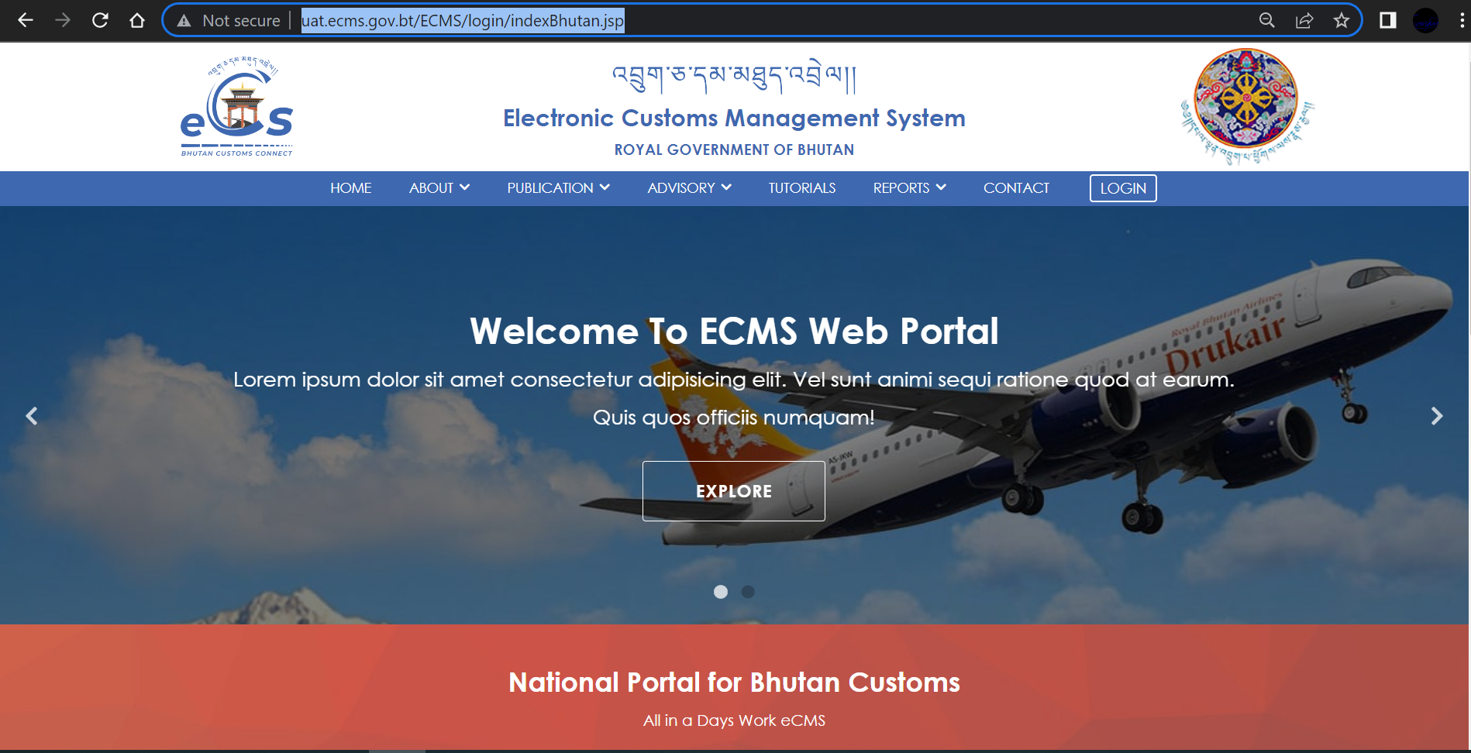

Fig.1. eCMS Landing page

- Click>>> LOGIN available on the top right corner of the landing page

  - Click >>LOGIN, the following login screen (Figure 2) is displayed

eCMS Login

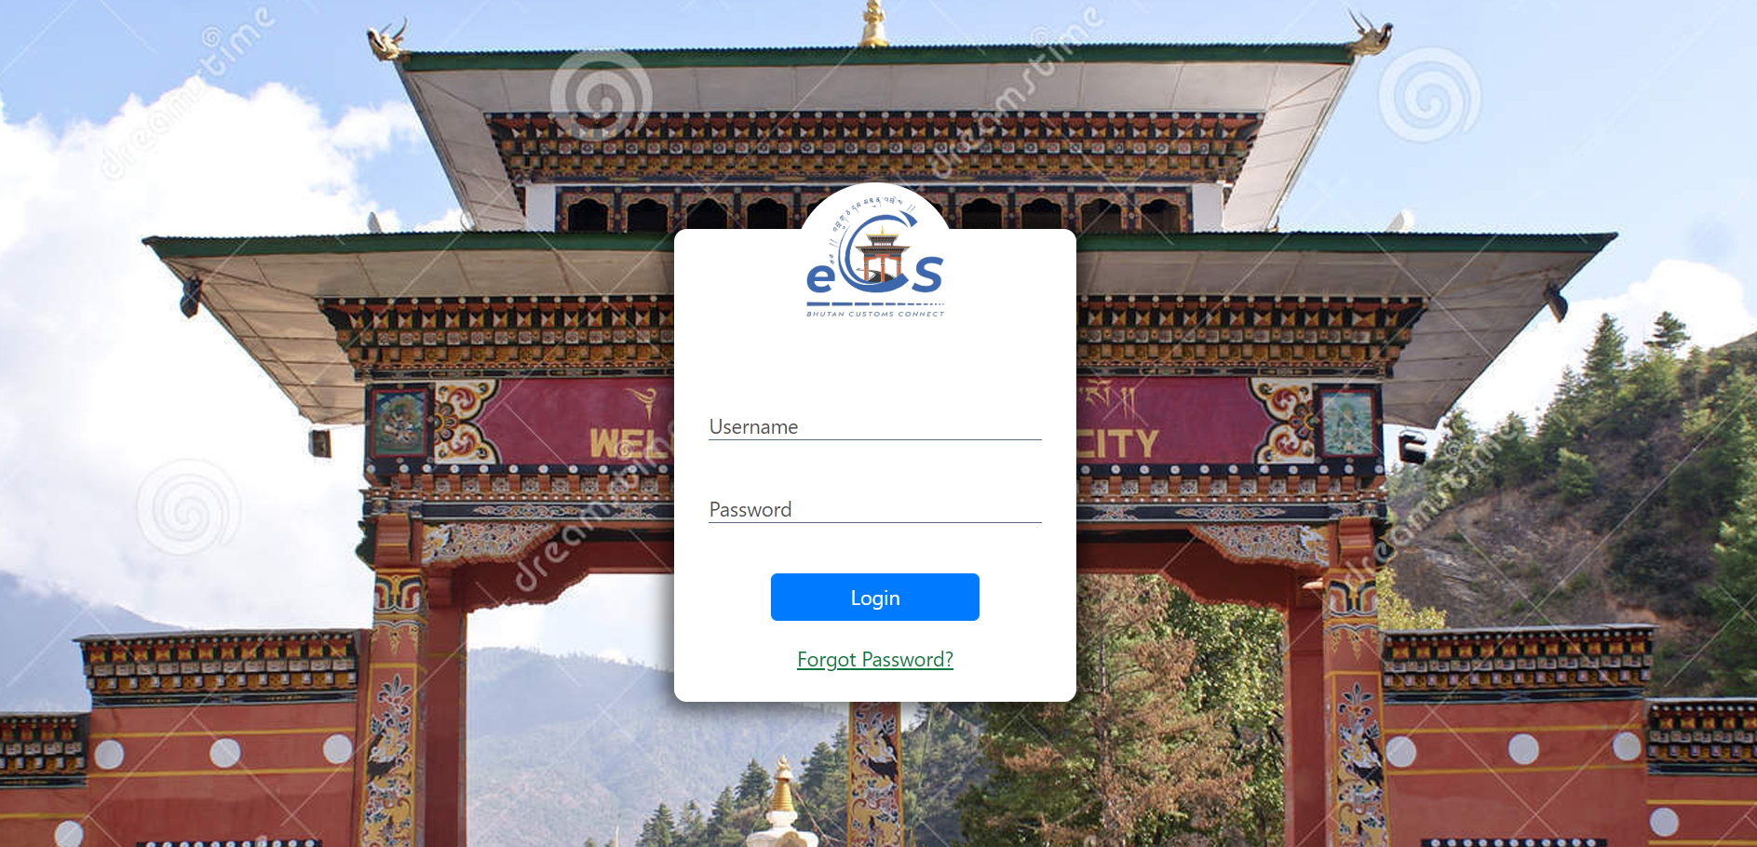
fig.2. eCMS login Page

  - Enter the USERNAME and the PASSWORD in the fields provided and Click button.

@ | In case you need to reset or forgot your password, On the login page, the user clicks the Forgot Password? link to start the process. The new password will be sent to your registered email.

Forgot/Reset password?
- If User Password is expired or forgot , Click >>“Forgot Password?”, “Forgot password Form” is displayed as shown in the figure 3 above.

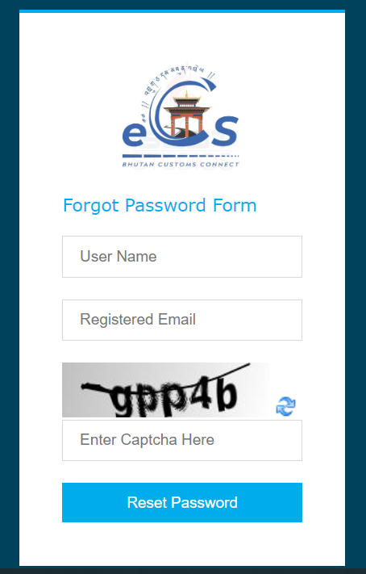
Fig.2. Forgot Password Form.
- Fill in the required details “User Name”, “Registered Email”, “Enter Captcha” and click on “Reset Password” Buttom. The subsequent screen is displayed;
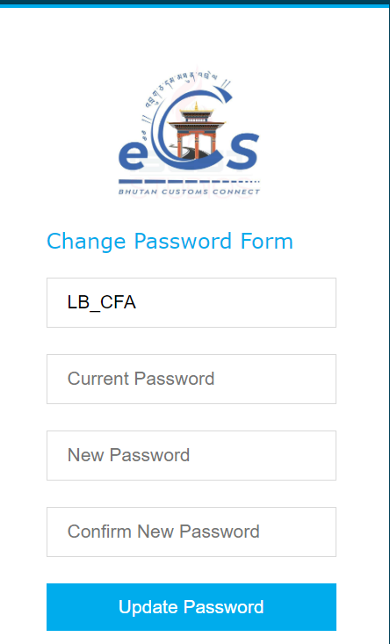
Fig.3. Update password

- Check your email for the password provided by the system and input in “Current Password” Field.
- Set your New Password and Confirm New Password.

- Click >> Update Password, the initial login page is displayed as below;

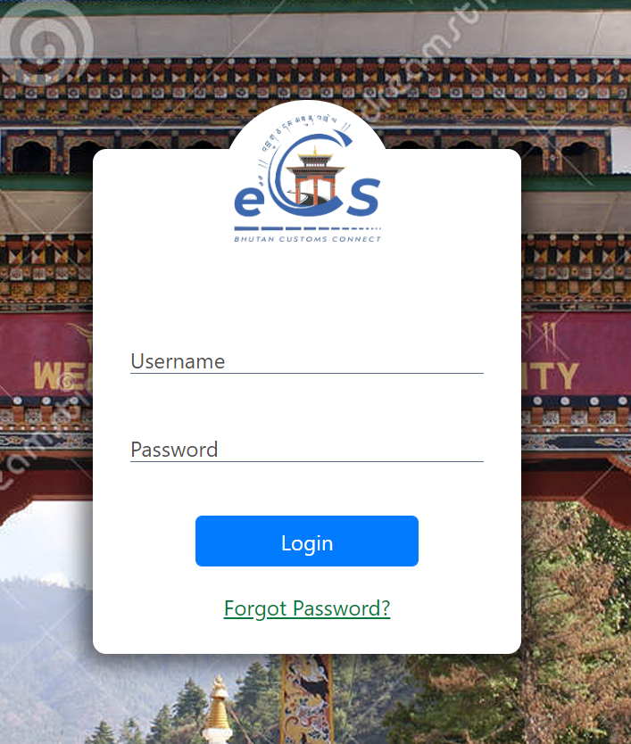
Fig.4. eCMS Login Page
- Enter the USERNAME and the NEW PASSWORD in the fields provided and Click “LOGIN” button.

Click>> LOGIN

- Upon successful login the Electronic Customs Management System Home Page will be displayed as shown below.
Dashboard Page

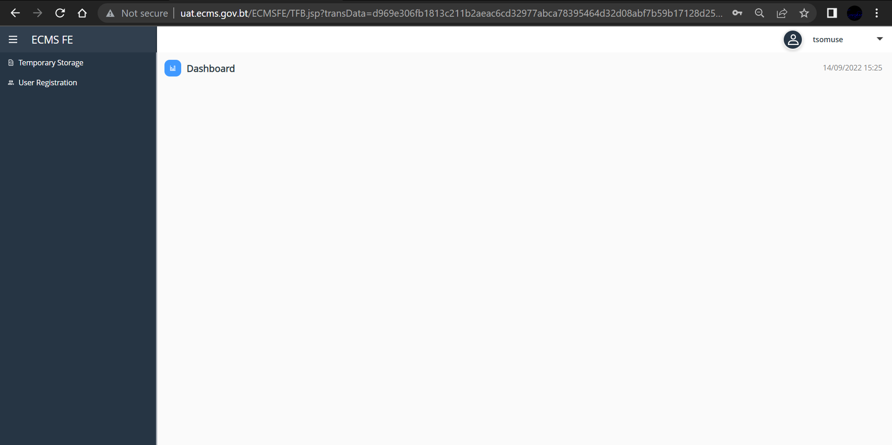
Fig.5. eCMS Dashboard (TSO)

Chapter 3- Accept Temporary Storage.

Admit Goods by TSO
- Go to Temporary Storage menu and click on “Admit Goods”. Subsequent Screen is displayed with the list of Submit goods request in the dashboard.
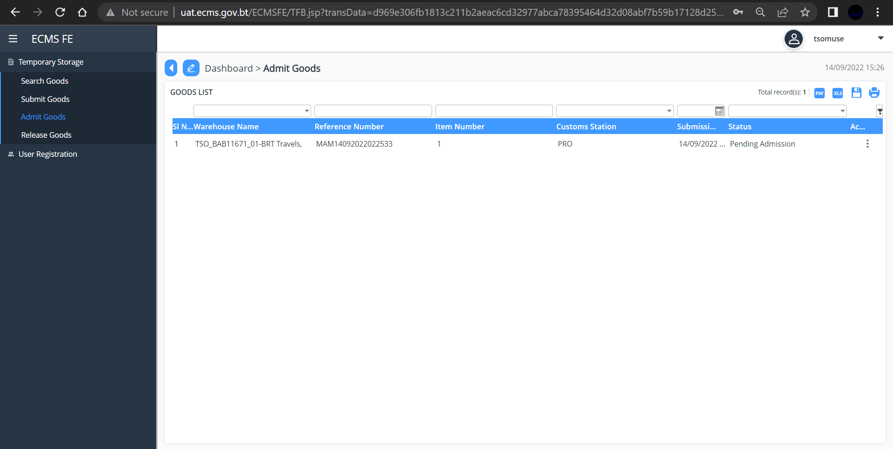
Fig.6. TSO Admit goods Dashboard
- Click on the Good list or Click on the three dots available on the extreme right of the good list, subsequent screen is displayed
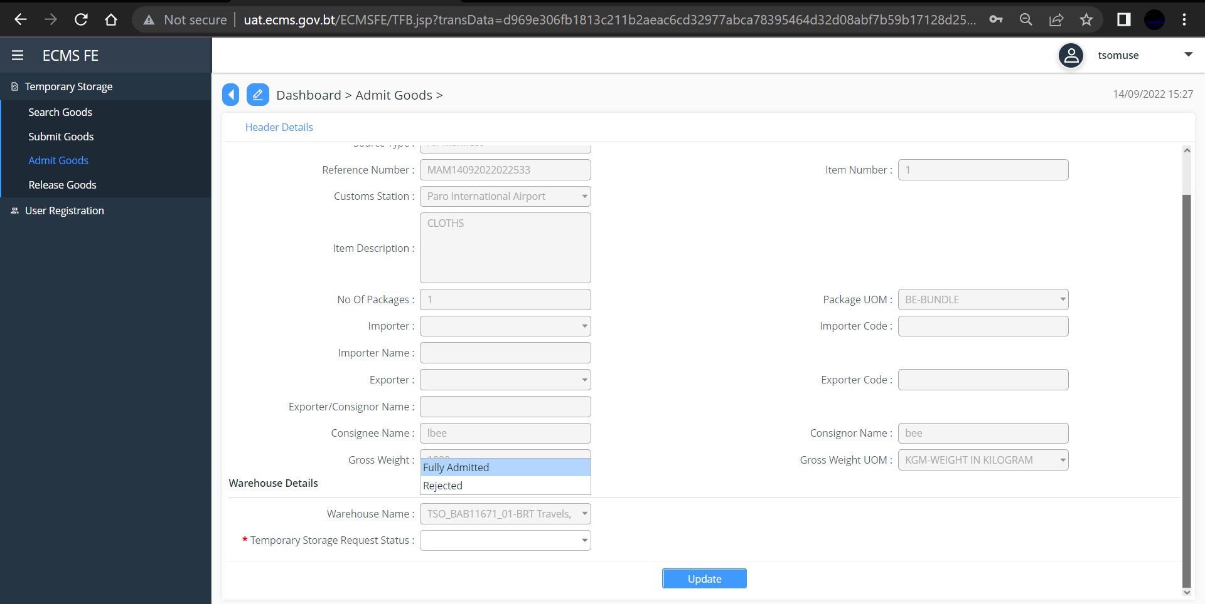
Fig.7. TSO Header Details
- Under Warehouse Details, in the “*Temporary Storage Request Status” select the Options and Click “Submit” Button, subsequent screen is displayed.

